KUBERNETES – TASK – 03
==================================================================================

- Create a ClusterIP service for an Apache web server pod.

vi apache-app.yaml
Paste the following content:

apiVersion: v1
kind: Pod
metadata:
name: apache-pod
labels:
app: apache
spec:
containers:
- name: apache
image: httpd
ports:
- containerPort: 80
---
apiVersion: v1
kind: Service
metadata:
name: apache-clusterip
spec:
type: ClusterIP
selector:
app: apache
ports:
- port: 80
targetPort: 80
Save and exit.

Apply the YAML
- kubectl apply -f apache-app.yaml
- kubectl get pods

Verify Service
- kubectl get svc

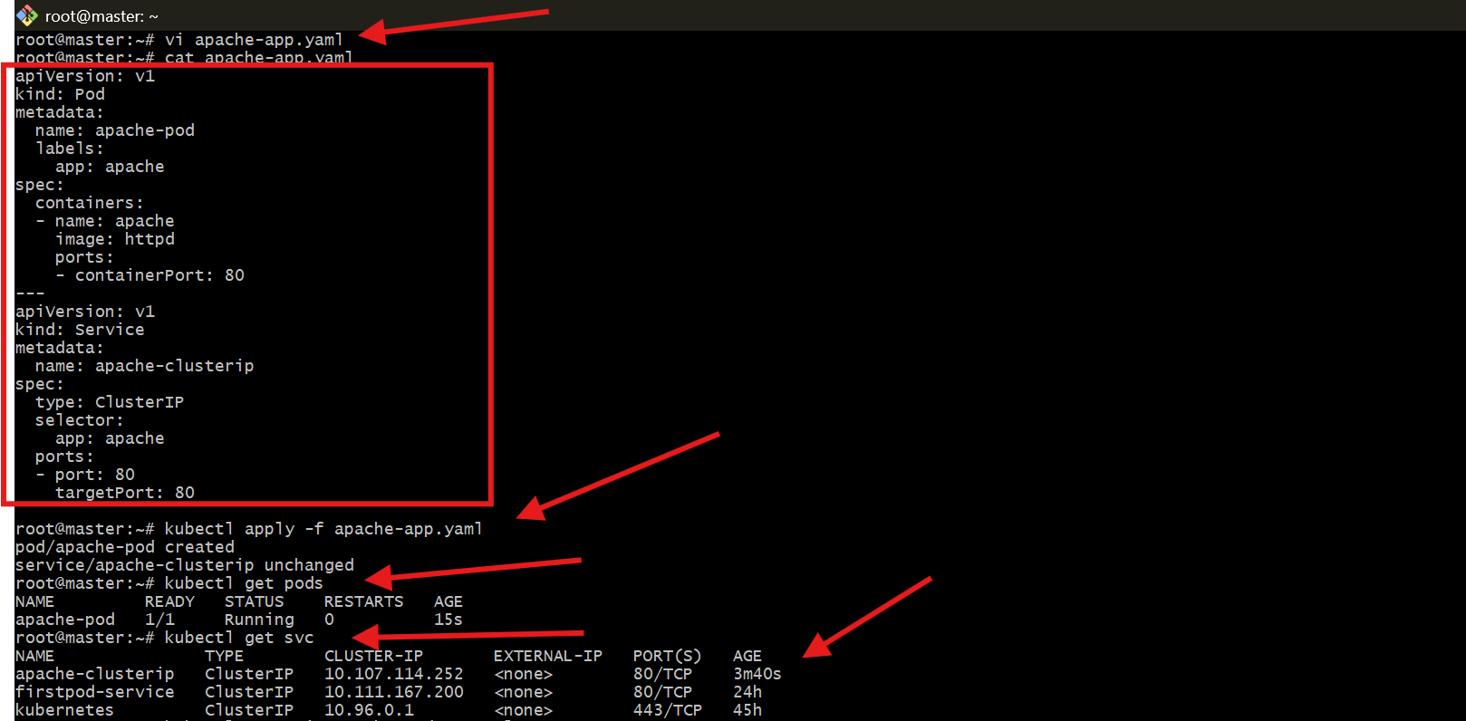
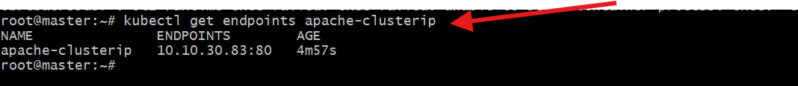

- Expose an Nginx pod externally using a NodePort service.
vi nginx-nodeport.yaml
Paste:

apiVersion: v1
kind: Pod
metadata:
name: nginx-pod
labels:
app: nginx
spec:
containers:
- name: nginx
image: nginx
ports:
- containerPort: 80
---
apiVersion: v1
kind: Service
metadata:
name: nginx-nodeport
spec:
type: NodePort
selector:
app: nginx
ports:
- port: 80
targetPort: 80
nodePort: 30007
Save and exit.

Step 2: Apply YAML
kubectl apply -f nginx-nodeport.yaml
Step 3: Verify
kubectl get pods
kubectl get svc
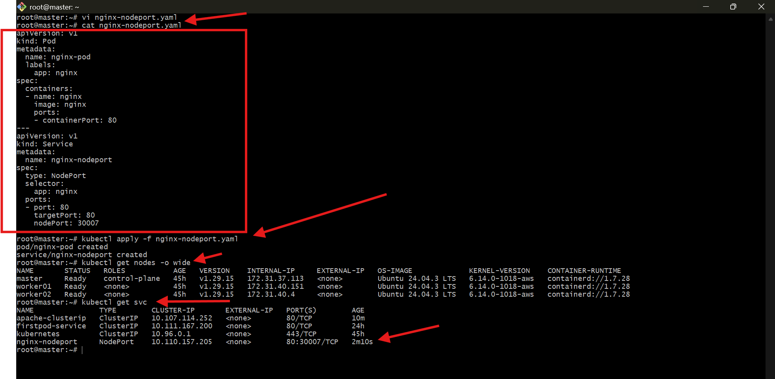

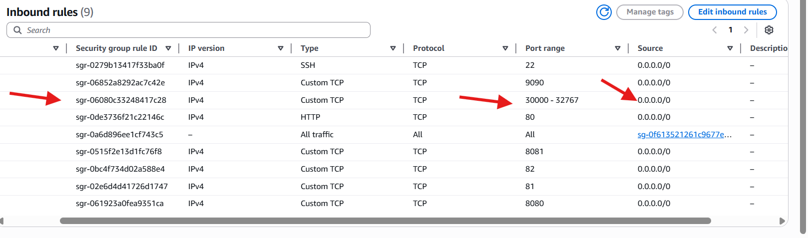

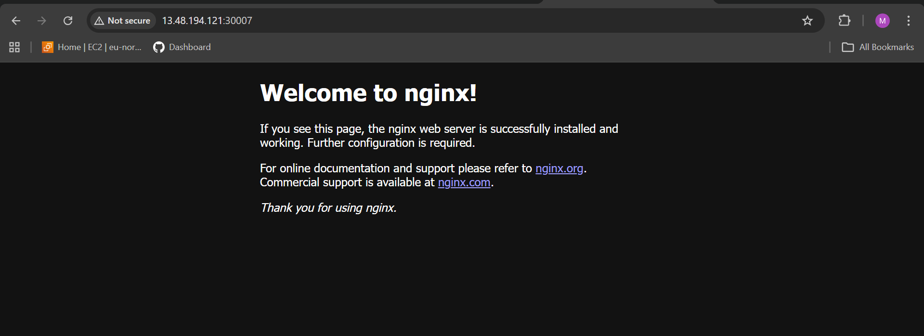

- Deploy a ReplicationController to maintain 3 replicas of an Nginx pod.
vi nginx-rc.yaml
Paste:

apiVersion: v1
kind: ReplicationController
metadata:
name: nginx-rc
spec:
replicas: 3
selector:
app: nginx-rc
template:
metadata:
labels:
app: nginx-rc
spec:
containers:
- name: nginx
image: nginx
ports:
- containerPort: 80
Save and exit.

Step 2: Apply YAML
kubectl apply -f nginx-rc.yaml
Expected output:

replicationcontroller/nginx-rc created
Step 3: Verify Pods
kubectl get pods
You should see 3 pods created automatically:

nginx-rc-xxxxx 1/1 Running
nginx-rc-yyyyy 1/1 Running
nginx-rc-zzzzz 1/1 Running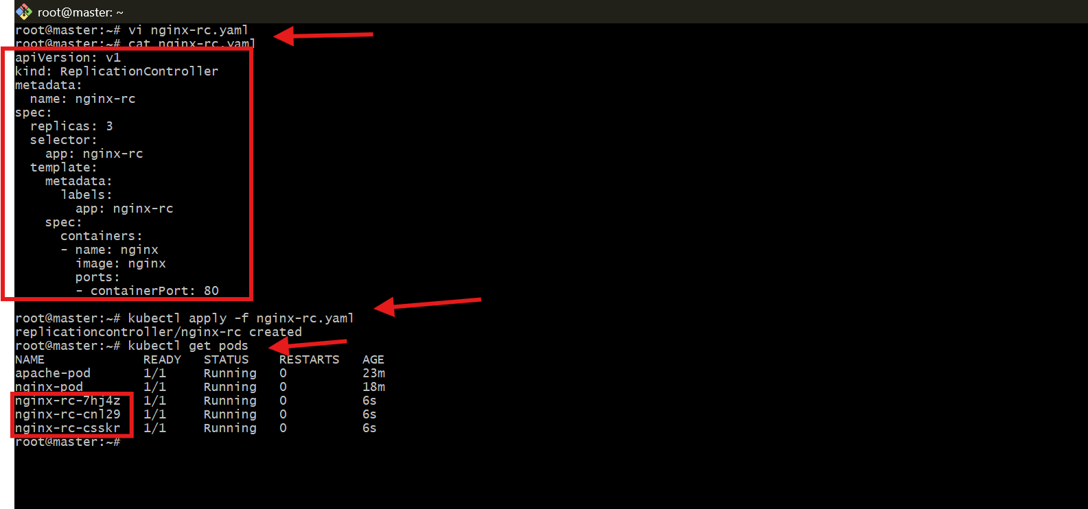

- Scale the ReplicationController from 3 replicas to 5 replicas.
- kubectl scale rc nginx-rc --replicas=5
Output:

replicationcontroller/nginx-rc scaled
Step 2: Verify Pods
- kubectl get pods
Now you will see 5 running pods:

nginx-rc-xxxxx 1/1 Running
nginx-rc-yyyyy 1/1 Running
nginx-rc-zzzzz 1/1 Running
nginx-rc-aaaaa 1/1 Running
nginx-rc-bbbbb 1/1 Running
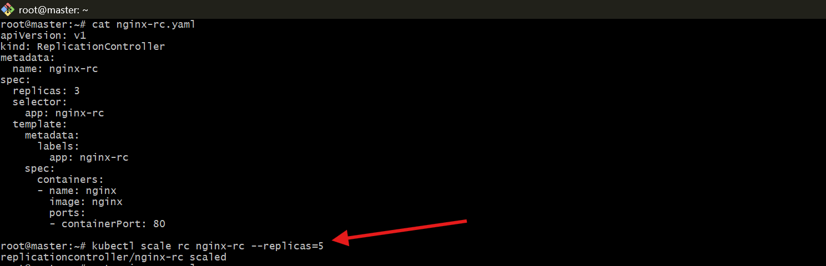

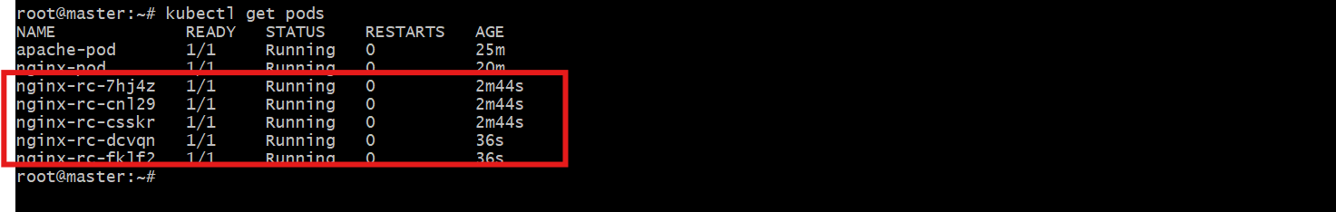
- Create a ReplicaSet to manage pods based on multiple labels (prod and test).

Step 1: Create YAML File
vi multi-label-rs.yaml
Paste:
apiVersion: apps/v1
kind: ReplicaSet
metadata:
name: multi-label-rs
spec:
replicas: 3
selector:
matchLabels:
app: nginx
environment: prod
template:
metadata:
labels:
app: nginx
environment: prod
spec:
containers:
- name: nginx
image: nginx
Save and exit.

Step 2: Apply YAML
kubectl apply -f multi-label-rs.yaml
Output:
replicaset.apps/multi-label-rs created

Step 3: Verify ReplicaSet
kubectl get rs
Example:
NAME DESIRED CURRENT READY
multi-label-rs 3 3 3

Step 4: Verify Pods
kubectl get pods
You will see 3 pods created:
multi-label-rs-xxxxx 1/1 Running
multi-label-rs-yyyyy 1/1 Running
multi-label-rs-zzzzz 1/1 Running

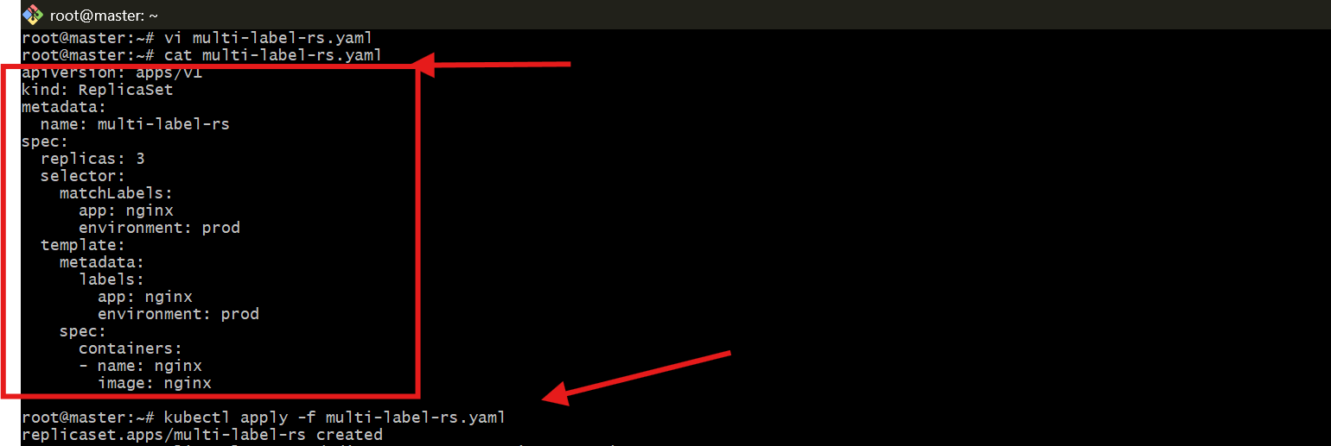

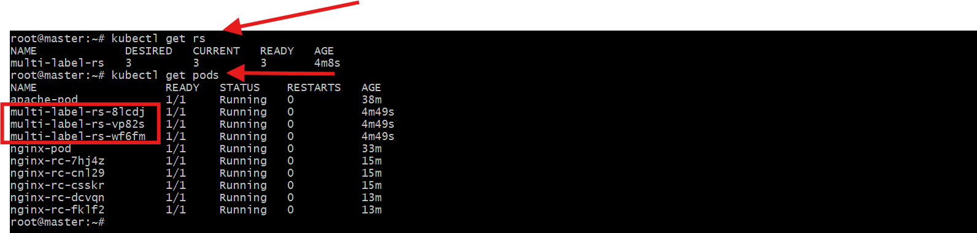

- Deploy a ReplicaSet that excludes pods with the label backend.
Step 1: Create YAML File
vi exclude-backend-rs.yaml
Paste:
apiVersion: apps/v1
kind: ReplicaSet
metadata:
name: exclude-backend-rs
spec:
replicas: 3
selector:
matchExpressions:
- key: tier
operator: NotIn
values:
- backend
template:
metadata:
labels:
tier: frontend
spec:
containers:
- name: nginx
image: nginx
Save and exit.

Step 2: Apply YAML
kubectl apply -f exclude-backend-rs.yaml
Output:
replicaset.apps/exclude-backend-rs created

Step 3: Verify ReplicaSet
kubectl get rs
Example:
NAME DESIRED CURRENT READY
exclude-backend-rs 3 3 3

Step 4: Verify Pods with Labels
kubectl get pods --show-labels
You will see:
exclude-backend-rs-xxxxx 1/1 Running tier=frontend

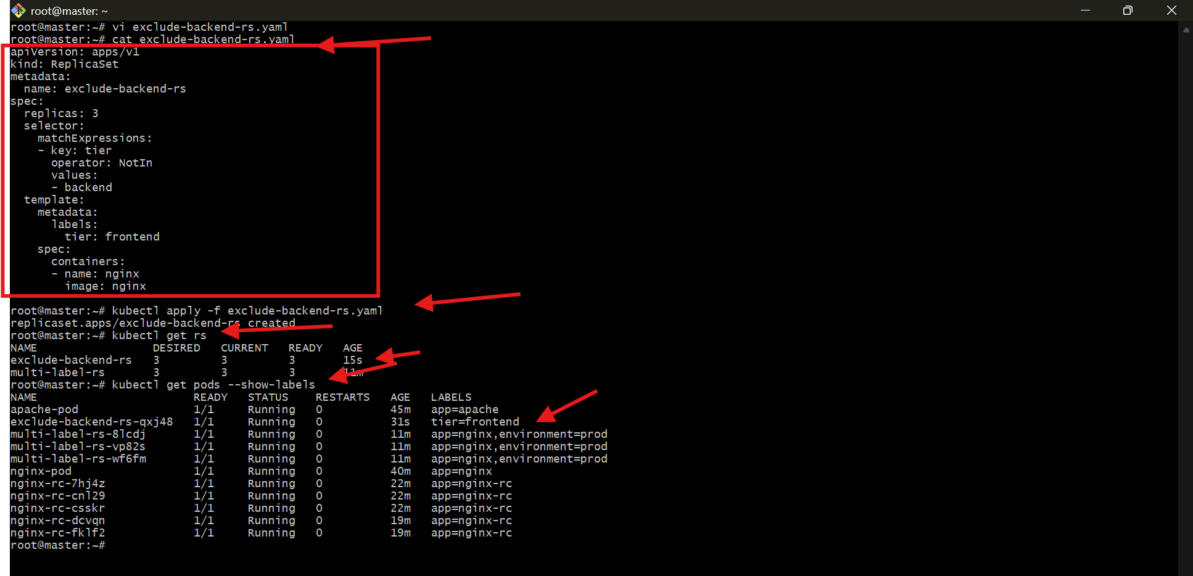
- Test load balancing across multiple pods using a NodePort service.

Step 1: Create YAML File
vi lb-nginx.yaml
Paste:
apiVersion: apps/v1
kind: Deployment
metadata:
name: nginx-deploy
spec:
replicas: 3
selector:
matchLabels:
app: lb-nginx
template:
metadata:
labels:
app: lb-nginx
spec:
containers:
- name: nginx
image: nginx
ports:
- containerPort: 80
---
apiVersion: v1
kind: Service
metadata:
name: lb-service
spec:
type: NodePort
selector:
app: lb-nginx
ports:
- port: 80
targetPort: 80
nodePort: 30008
Save and exit.

Step 2: Apply YAML
kubectl apply -f lb-nginx.yaml
Output:
deployment.apps/nginx-deploy created
service/lb-service created

Step 3: Verify Deployment
kubectl get deploy
Expected:
NAME READY UP-TO-DATE AVAILABLE
nginx-deploy 3/3 3 3

Step 4: Verify Pods
kubectl get pods -o wide
You will see 3 pods running on worker nodes.

Step 5: Verify Service
kubectl get svc
Example:
lb-service NodePort 10.x.x.x <none> 80:30008/TCP

Step 6: Open AWS Security Group
Add inbound rule:
- Type: Custom TCP
- Port: 30008
- Source: 0.0.0.0/0

Step 7: Access in Browser
http://<EC2-Public-IP>:30008

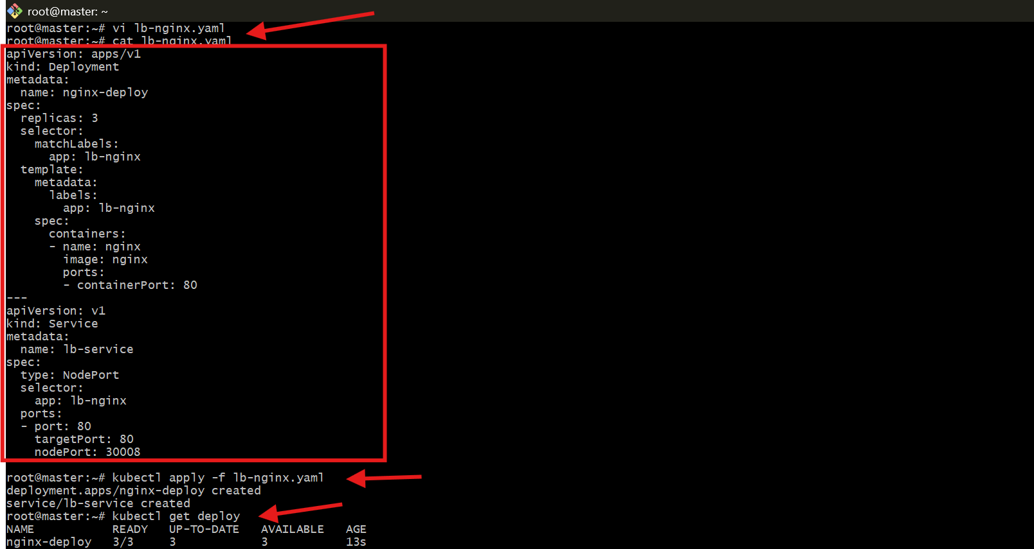

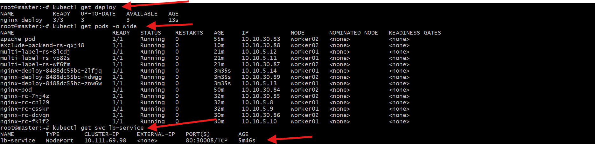
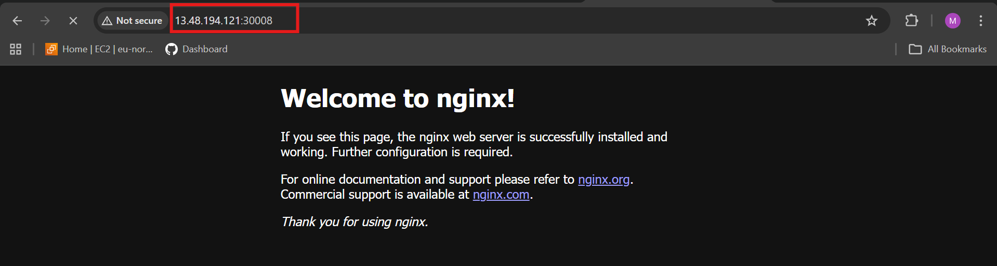

- Delete a ReplicationController without affecting the running pods

kubectl delete rc nginx-rc --cascade=orphan
What This Command Does
Deletes only the ReplicationController

Keeps the pods running

Pods become independent (no controller managing them)

Step 1: Delete RC Without Affecting Pods
kubectl delete rc nginx-rc --cascade=orphan
Output:

replicationcontroller "nginx-rc" deleted
Step 2: Verify Pods Still Running
kubectl get pods
You will still see:

nginx-rc-7hj4z 1/1 Running
nginx-rc-cn129 1/1 Running
(As shown in your screenshot)

Important Concept: Cascade Deletion
Default Behavior (Foreground Deletion)
kubectl delete rc nginx-rc
Deletes RC

Deletes all pods managed by it

Orphan Mode
kubectl delete rc nginx-rc --cascade=orphan
Deletes RC only

Leaves pods running

Pods are no longer managed

